**Circular Linked List**

Singly Linked List as Circular

In singly linked list, the next pointer of the last node points to the first node.

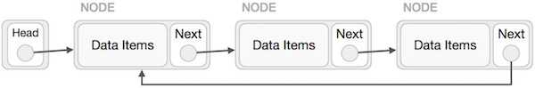

Doubly Linked List as Circular

In doubly linked list, the next pointer of the last node points to the first node and the previous pointer of the first node points to the last node making the circular in both directions.

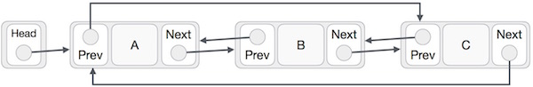

As per the above illustration, following are the important points to be considered.

* The last link's next points to the first link of the list in both cases of singly as well as doubly linked list.
* The first link's previous points to the last of the list in case of doubly linked list.

Basic Operations

Following are the important operations supported by a circular list.

* **insert** − Inserts an element at the start of the list.
* **delete** − Deletes an element from the start of the list.
* **display** − Displays the list.